Kol simcha torah gazette
For parshas ki seitzei 5784
Volume 8 Issue 51 (Whole #411) 11 Elul 5784/ September 14, 2024
Printed L’illuy nishmas Nechama bas R’ Noach, a”h

For a free subscription, please forward your request to keren18@juno.com
Past emails can be found on the website ShabbosStories.com under Brooklyn Torah Gazette
Essential Lessons for this Elul
By Daniel Keren

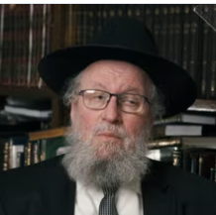
Rabbi Elya Brudny

The second featured speaker at the Flatbush Labor Day Hakhel Yarchei Kallah Event was Rabbi Elya Brudny, Rosh Yeshiva of Yeshivas Mir in Brooklyn. He spoke on the timely topic of “Yemei Harachamim and HaSlichos: Essential Lessons for This Elul.”
He noted that it is very rare that Rosh Chodesh Elul comes so early in the secular month of September. The month of Elul – what is our job to utilize it in leading us up to the Yom Hadin (Rosh Hashanah)? We hope that we have done enough preparation to get us through Rosh Hashanah. We can only hope that we use these precious days of Elul profitably.
To understand how one can utilize the days of Elul effectively, Rabbi Brudny suggested that one study the hakdama or introduction of the classic mussar sefer “Mesilas Yesharim.” It was authored by the Ramchal – Rav Moshe Chaim Luzzatto (1707-1746).

What Does Hashem Want of Us?
He is writing to a person who is not aware of the significance of his actions. His first perek (chapter) explains that a person can’t get into improving himself unless he knows the basic truths of what does Hashem want of us in order to live a proper life. We are not here except to prepare ourselves for Olam Habah, the World to Come. It is like Shabbos that requires us to do the work of preparing and cooking our food before the advent of Shabbos in order to enjoy the festive Sabbath meal when we can no longer cook at that time.
What we say and how we say it and how we think is most important, Rabbi Brudny said, for anyone who wants to be a refined frum Yid. Such a person must study the hakdama of Mesilas Yesharim. The author says that one must ask himself why is he here and what is the purpose that Hakodesh Baruch Hu sent me into this world to accomplish?

The Non-Jews Are Guilty for the Way They Treat Us
Question #1 is Mah hu? What is he (the individual?} The whole world, Rabbi Brudny said referring to the majority of the population (non-Jews) are guilty for the way they treat us (the Jewish nation.) But what about us, a handful of Shomrei mitzvos? How are we to understand this important question. The Ramban writes that what Hakodesh Baruch Hu did to the Mitzrayim [by punishing the Egyptians for how they mistreated the Bnei Yisroel, the Children of Israel] should make us aware of the fact that a human being should internalize that he was created. Adam Hashem was created by Hashem in a special surgery. And Chava was also created by Hashem in a second unique surgery.
Everything that we daven (pray) about is our declaration that Hashem created us and the whole world. Most of the eight billion people living today do not understand this important concept – one that we as Jews must incorporate into our consciousness.
Who am I to decided what I want to do? Even if it is OU Pareve! There mere fact that I need anything that some foolish non-Jew came up with in order to make our lives more pleasurable is questionable. Our challenge is to live in a culture and be anti-that culture. Try do daven on time and aim not be do a factory [mindless] type of davening.

Why Are We Considered By
Hashem to be His Children?
Hashem messages that [in Parshas Re’eh] that we are banim lamakom (children to G-d.) The non-Jews had a custom when they lost a close relative to pull out their hair in grief and make scars in their scalps. But we (Jews) don’t do that because we are children to Hashem. Why are we considered His children and the non-Jews are only His creations?
What is the definition of a person? Is it that he is a live person? Life is eternal! There is a tefukah (period in time) when one’s body lives in this world. But when a person dies, he simply leaves this world. It is like a person who leaves his family and goes [like in the days before airplane travel] to the other side of the world where he will never physically see his beloved family again [in this world]. A place where there are no phones to communicate with those he loves so much.

A Jew is More than Just a Physical Body
Yet he is able to send money back to benefit his family in this world [and where his family can reward the departed by the mitzvos they continue to perform in this world.] A Jew is not primarily a guf (physical body) like the non-Jews, but rather an eternal neshama (soul) that is also an intrinsic banim la Hashem. Our job is to deeply internalize this emes (truth).
Klal Yisroel is bleeding and suffering! We are still reeling [from the tragedy of last Simchas Torah/October 7th.] We don’t [seemingly] see the end in sight. Let us hope that in these days of Elul we can be worthy to do teshuva and merit to see tremendous yeshuos (salvations) with the rest of Klal Yisroel.

Reprinted from this week’s edition of The Flatbush Jewish Journal.

*****************************************************************

You shall make for yourselves twisted threads... (22:12) R' Ephraim of Luntschitz z"l (17th century; author of Kli Yakar) writes that the five knots of the tzitzit allude to five "marriages": 1) the Jewish people to the Torah; 2) the Jewish people to Hashem; 3) the Jewish people to Yerushalayim; 4) the body to the soul; and 5) man to woman. (Olelot Ephraim)

Reprinted from this week’s email of R’ Yedidye Hirtenfeld’s whY I Matter parsha sheet for the Young Israel of Midwood in Brooklyn, NY.
Rabbi Berel Wein on
Parshat Ki Tetzei 5784

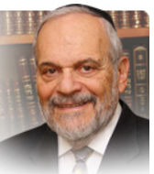

In this week’s parsha, the Torah portrays for us an accurate and unforgiving view of war and its personal consequences. No one who participates in a war escapes unscathed from these consequences. The ones who are killed or wounded have suffered these consequences on their very physical bodies. But even those who have survived the battle whole are affected by the consequences of that struggle.

That is the supremely important, albeit subliminal message of the beginning of this week’s parsha. A Jewish soldier, who according to the ritual requirements of becoming such a soldier and being accepted for the battle as outlined in last week’s parsha, a G-d-fearing patriotic and observant person, somehow enters into a sexual relationship with a non-Jewish woman, a relationship which Rashi points out to us will only bring him future grief and regret.

The heat and passions that war and combat engender within a person cannot be limited to the actual battlefield alone. They carry on within the psyche and body of the combatant and find different ways of expression in all other areas of human life and experience.

The observant Jew, who under ordinary and usual non-combat circumstances is scrupulously pious and moral in one’s behavior, now becomes a sexual predator and enters into a physical relationship with a non-Jewish stranger. Is this not the strongest message possible that the Torah wishes to communicate to us about the consequences and effects of war!?

War requires the abandonment of personal inhibitions. That will help explain the scenario portrayed for us by this opening parsha of this week’s Torah reading. Without inhibitions there can be no morality or piety.

But as all of us living here in Israel are well aware of, war is a constant state of affairs in our national and personal life. The Jewish people have been at war here in the Land of Israel for almost all of the years of the past century. These wars may not be of our choosing or our initiative but they are omnipresent in our lives and society.

And because of this difficult state of affairs, Israeli society has been affected and even shaped by the presence of constant combat and warfare. Much of the rough spots that still exist in our society – the divisiveness, the absence of mannered courtesy, the unnecessary assertiveness, etc. – are all consequences of our being in a constant state of war. Inhibitions and piety are hard to maintain under such conditions and consequences.

Peace is not merely an absence of a hot war. It is a state of mind that induces tranquility, rationality and all-around general goodness. That is why peace is so exalted in the works of the prophets and throughout the Talmud and Jewish tradition. And that is why we pray three times daily that its presence should be felt amongst us. With peace – both inner and outer – such events as portrayed for us at the beginning of this week's parsha simply do not occur.

There are no people that long for peace as greatly as do the people of Israel. May the L-rd somehow bless us with the achievement of peace and thereby restore us to normalcy, piety and eternal goodness.

Shabbat shalom

Reprinted from the current rabbiwein.com website.

Rav Avigdor Miller on What Should We Think When Hearing the Shofar Being Blown During Chodesh Elul?

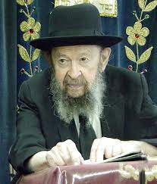

When you hear the shofar being blown there are many things to think about; not one thing. But the first thing you have to think is ָ — Could it be that they blow a shofar in the city and the people are not afraid?! (Amos 3:6). You have to be afraid right away! Eimas hadin – fear of the judgment. It’s very important. The day is coming and you have to be afraid; you must be afraid.
Now, being afraid however, has to have some practical results. You’re saying in selichos all the time something that you never do. – We will search out our ways. Do you search your ways? You never do it! Did you sit down for five minutes once in your life and search out your ways? Never! Oh, but he’s saying selichos;.” Mmmmuh mmmmuh. He’s mumbling the words. What a pity.

A Five-Minute Inventory
So, the shofar says, “Start searching your ways!” At least five minutes. Five minutes by the way is a very small time to make an inventory on your business. A businessman who makes a five-minute inventory will go broke. He needs much more than five minutes. But at least five minutes! At least you shouldn’t be a shakran. The whole world is deceiving Hashem – With his mouth and his lips he honors Me; he says “I will search out my ways,”– but his heart is far away from Me (Yeshaya 29:13). He doesn’t think about it at all. It’s a terrible thing.
So, when you hear the shofar, think about your ways. Why is it that people, frum people, live their entire lives in sin. He’s trying to kill his wife by saying mean words to her and she wants to shorten his life by saying mean words to him. They don’t want to do it chas v’shalom, but that’s what they’re doing – they’re hurting each other. A whole life of ona’as devarim. Each time you say it it’s a terrible sin. A terrible sin to say mean words to each other. And it’s being done in so many houses!
Nachpisah! If you search you’ll find. It’s terrible what’s going on in the houses. People hurt each other’s feelings tremendously. And don’t think it doesn’t have an effect on that person’s health. It affects the health; sure, it does. And therefore, there’s no lack of things to discover. Once you search, you’ll find. Oh yes, there’s plenty to find.

Reprinted from a Parshas Ki Seitzei 5784 email of Toras Avigdor (Tape #E-124 – September 1997)

Thoughts that Count
for Our Parsha

But he shall acknowledge the son of the hated for the firstborn (bechor), by giving him a double portion of all that he has (Deut. 21:17)
Even the letters of the word "bechor" allude to the firstborn's inheritance of a double portion, as each letter is numerically equivalent to double the one that immediately precedes it in the Hebrew alphabet: beit (2) is twice alef (1); chof (20) is twice yud (10); and reish (200) is twice kuf (100). (HaGra)

You shall not watch your brother's ox or his sheep go astray and hide yourself from them; you shall surely bring them back to your brother (Deut. 22:1)
This is the mitzva of "returning a lost object." If the Torah commands us to return a lost physical object and not pretend we are unaware of the situation, how much more so are we obligated to help a lost Jewish soul and restore it to its rightful place. (The Shaloh)

But you shall let the mother go, and take the young to you (Deut. 22:7)
What is the reward for sending the mother bird away from the nest? "If you are childless, I will give you children. By fulfilling this commandment, you thereby hasten the arrival of King Moshiach...and the Prophet Elijah." (Midrash Rabba)

Reprinted from the Parashat Ki Teitzei 5761/2001 edition of L’Chaim

The Jew’s Lifelong Battle
Against the Evil Inclination
From the Teachings of the Lubavitcher Rebbe
Rabbi Menachem Mendel Schneerson, Zt”l
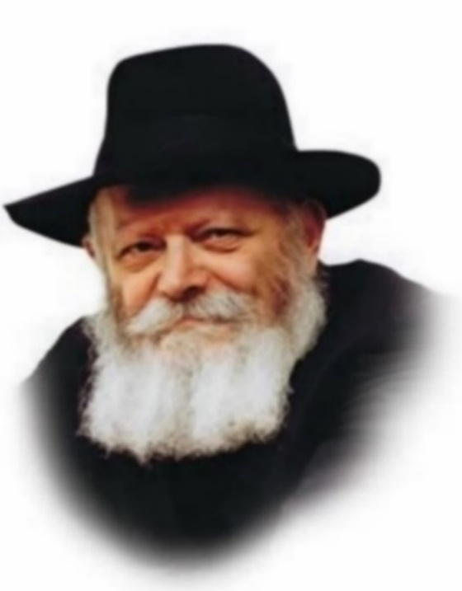

The opening verse of this week's Torah portion, Ki Teitzei, begins "When you go forth to battle against (al) your enemies." Significantly, the Torah uses the word "al," literally "upon" or "above," rather than "with" or "against."
This contains an allusion to the ongoing "battle" every Jew must wage against his true enemy, the Evil Inclination:

The Arguments of the Evil Inclination
A Jew might claim that it is very difficult for him to study Torah and do mitzvot, given that he lives in a non-Jewish world. Then he must also contend with his Evil Inclination, which continually tries to convince him that he doesn't need to conduct himself as a Jew. "The non-Jews don't keep kosher," the Evil Inclination says, "why should you?"
Furthermore, the Evil Inclination is a "skilled craftsman," meaning that he is very good at his job. The Evil Inclination doesn't always present himself as an enemy; in fact, he is at his most dangerous when he disguises himself as a friend. Sometimes, the Evil Inclination will even pretend to the Good Inclination, whose only desire is to improve the person's behavior. This is the worst evil one can inflict on someone, making believe he is a true friend while actually causing him harm.
A Jew might ask, "How am I supposed to protect myself from the Evil Inclination? And how can I be sure whether a suggestion is coming from the Evil Inclination or the Good Inclination?"
Then, of course, there is a more fundamental question: Why did G-d create an Evil Inclination in the first place? Wouldn't it have been better if people had only a Good Inclination, and instead of fighting negative impulses and having to overcome them, all their time could be spent learning Torah and doing mitzvot?
To which the Torah answers, "When you go forth to battle upon your enemies."
A Life-Long Battle Against the Evil Inclination
G-d tells every Jew: Yes, it is true that you will have to wage a life-long battle against the Evil Inclination. But you should know that as soon as you determine to fight him, at the very moment you resolve to wage war against your true adversary, the Evil Inclination, you will automatically be raised to a superior position. And in the same way that it is easier to vanquish a physical enemy from an elevated position, so too will it be easy to defeat the Evil Inclination, with G-d's help.
As soon as a Jew resolves to fight his Evil Inclination, the battleground is already tilted in his favor. G-d makes him stronger than his adversary, and he has nothing to fear. All of his time can then be utilized for learning Torah and doing mitzvot.

Reprinted from the Parashat Ki Teitzei 5761/2001 edition of L’Chaim, a publication of the Lubavitch Youth Organization in Brooklyn. Adapted from a talk of the Lubavitcher Rebbe on 7 Elul 5750.

******************************************************************
“If you build a new house, you shall make a fence for your roof.” (22:8) R’ Naphtali Zvi Horowitz z”l (1760-1827; Ropshitzer Rebbe) writes: “Building a new house” refers to rebuilding the Bet Hamikdash through the good deeds we do. We pray, “Build it speedily b’yameinu,” usually translated, “in our days.”
However, this also can mean, “Build it speedily with our days,” i.e., the good deeds with which we fill our days are the construction materials with which the Third Temple is being built. The Ropshitzer continues:
The verse says that when you do the good deeds that will become the building blocks of the future Bet Hamikdash, “You shall make a fence for your roof.” This teaches that your spiritual ascent should not be public; rather, you should conceal your good deeds behind a barrier of humility and discretion. (Zera Kodesh)
Reprinted from this week’s email of R’ Yedidye Hirtenfeld’s whY I Matter parsha sheet for the Young Israel of Midwood in Brooklyn, NY.
The Nazi’s Jewish Son
By Yehudis Litvak

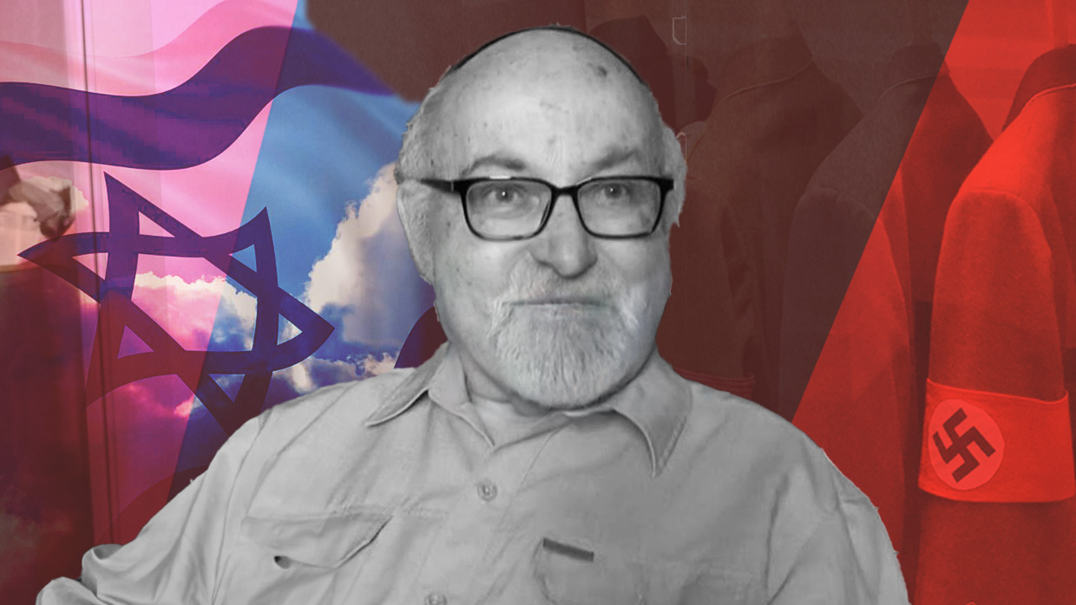
Rabbi Dr. Aharon Shear Yashuv was born Wolfgang Shmidt in Germany. His interest in the Holocaust sparked his journey to becoming a member of the Jewish people.

There are many stories of children of Nazis who completely rejected their parents’ beliefs and distanced themselves from their actions. Some went so far as to convert to Judaism and join the Jewish people.
Most of these converts prefer to remain anonymous. They would rather erase their Nazi connections completely. A notable exception is Rabbi Dr. Aharon Shear Yashuv, Professor Emeritus of Jewish Philosophy at Bar-Ilan University, who is very open about his background. Born Wolfgang Shmidt in Bochum, Germany in 1940, he converted to Judaism and moved to Israel in 1970. Currently, Rabbi Dr. Shear Yashuv resides in Jerusalem’s Old City.
Rabbi Dr. Shear Yashuv’s father was a member of the Nazi party. He fought in the Nazi army during World War II and was captured and imprisoned in the Soviet Union for five years after the war. Though he saw him briefly at age 4, he didn’t really get to know his father till he was 10. They never had much of a relationship.

“There was not a special relationship, because whenever we talked about recent German history, there was silence… They didn’t like to talk about the Nazi period, and that was strange to me. So even as a youngster, I made some connections.”
To this day, Rabbi Dr. Shear Yashuv does not know to what extent his father was involved in the Holocaust. He’d heard rumors that his father participated in the SS but was not able to confirm them through historical research.

Learning about the Holocaust
As a young teenager, Rabbi Dr. Shear Yashuv was fascinated by history. That’s when he learned about the Holocaust. “I became more and more interested in Jewish questions… If you’re dealing with recent German history, you’re dealing with a Jewish question, because you’re dealing with the Holocaust, and the Holocaust is a Jewish affair.”
Growing up, Rabbi Dr. Shear Yashuv did not know any Jews personally. His town’s synagogue was destroyed on Kristallnacht and its Jewish residents were murdered in the Holocaust.
At around age 15, his interest in “Jewish questions” led him to visit a synagogue in a nearby town, where he met Jews for the first time. He continued coming to the synagogue on Shabbat, got to know the community members, and was often invited for Shabbat meals.
At the same time, Rabbi Dr. Shear Yashuv joined a Christian-Jewish youth group. In high school, he organized a group trip to Israel, where they stayed in a church’s guest house. This was before the Six Day War, when the Old City in Jerusalem was off limits to Jews. As Christians, the group was able to visit the Old City and the Western Wall. Jerusalem made a strong impression on Rabbi Dr. Shear Yashuv, and he knew he would be back.

He Studied Theology and Philosophy in College
Eventually, says Rabbi Dr. Shear Yashuv, “this historical interest in the Holocaust, which was the starting point of my approach to Judaism, became in the course of the years more theological-philosophical.” In college, he studied theology and philosophy. He analyzed and consciously rejected the Christian doctrine and found himself drawn to Jewish theology. He especially appreciated the concept of halacha – Jewish law which guides a religious Jew’s daily life.
“In Christianity, there is only love,” he explains. “But ‘love’ has to be spelled out. And it is not spelled out. And therefore, this whole concept of love is a failure in the history of the Church. Inquisition – that is love? Accusing Jews of poisoning wells – that’s love? The Crusades – that’s love? The Holocaust is a product of Christian Europe. Now comes Judaism, spelling out what love means in the daily law, which penetrates all realms of life… This is the great message of Judaism, and Christianity failed because they canceled it.”

Told by His Teachers to Go to
Either Israel or the United States
Rabbi Dr. Shear Yashuv realized that his experience of Jewish life in post-Holocaust Germany was very limited. He was looking for “a much more serious frame of Jewish existence,” and his teachers recommended that he go either to Israel or to the United States.
He applied and was accepted to a Ph.D. program at the Hebrew Union College in Cincinnati, OH, where he spent three years and completed a dissertation about a German Jewish philosopher. While in America, Rabbi Dr. Shear Yashuv thought about his future and eventually made two life-changing decisions: to convert to Judaism and to make aliyah – move to Israel.
Before making aliyah, Rabbi Dr. Shear Yashuv spent the summer in Israel, where he visited the Merkaz HaRav yeshiva in Jerusalem. “I was very much impressed. For the first time, I saw what a yeshiva was like. It’s not university!” He was fascinated by the chavruta system, where the students boisterously learn Jewish texts in pairs. Upon his move to Israel, Rabbi Dr. Shear Yashuv studied at the Merkaz HaRav for three years.

Strained Relationship with His Family Back in Germany
Meanwhile, his family in Germany was not happy with his choices. During a vacation from yeshiva, Rabbi Dr. Shear Yashuv decided to visit Germany, together with a friend from yeshiva. The two friends stayed with Rabbi Dr. Shear Yashuv’s sister in Dusseldorf. His parents were on vacation in a resort town, and his sister suggested that they pass through Dusseldorf on the way home in order to see their son.
When his father found out that he brought along a Jewish friend, he refused to see him. “He never left his Nazi ideology, even after the war,” says Rabbi Dr. Shear Yashuv.
Back in Israel, Rabbi Dr. Shear Yashuv spent a Shabbat in Hebron together with other yeshiva and university students. There, he met his future wife, a Hebrew University student whose family had come to Israel from Algeria after the War of Independence. They got married six months later. The Merkaz HaRav yeshiva organized a beautiful wedding for the couple, with participation of “all the famous rabbis,” but no one from Rabbi Dr. Shear Yashuv’s family attended his wedding.
The couple had five children. Rabbi Dr. Shear Yashuv spent six years in rabbinical studies, eventually receiving his ordination. He served as an army chaplain and as the rabbi of Technion, the Israel Institute of Technology.

Taught Philosophy at Bar Ilan University
“But my leanings remained academic,” says Rabbi Dr. Shear Yashuv. “The Technion is something of a bridge between rabbinate and the academic world.” He’d organized Torah studies for both students and professors but didn’t feel quite satisfied. He continues, “So after four years at the Technion, I tried to return to the academic world. Finally, I was accepted at Bar Ilan University Department of Philosophy, and there I remained almost 30 years, until I retired.” He is still in contact with the university. Though no longer teaching, he is involved in students’ dissertations.
While on faculty of Bar Ilan University, Rabbi Dr. Shear Yashuv spent two sabbatical years in Germany. When his wife and children joined him in Germany for the first time, his wife asked if she could meet his parents.
They drove for hours to his parents’ home, but once they got there, Rabbi Dr. Shear Yashuv could not bring himself to go inside. He recalls, “I remained in the car, and my wife with the little children went up to see my parents. They talked. My father was there. But because of my father, I couldn’t join that meeting.”
It was only several years later, after his father’s death, that Rabbi Dr. Shear Yashuv visited his mother together with his wife and children.
Now his mother is no longer alive. He keeps in touch with his sister’s family, who are much more accepting of his chosen lifestyle than his parents had been.

Completely Accepted by the Parent-in-Laws of His Children
Interestingly, Rabbi Dr. Shear Yashuv’s children married descendants of Holocaust survivors. He says, “All my grandchildren and great-grandchildren are descendants of survivors of the Holocaust.” He has warm relationships with his children’s parents-in-law and feels that they’ve completely accepted him and his family into their own families. “It speaks for the Jewish people,” he says. “I, of course, appreciate it very much. I never had any problems or hesitations from the Jewish side. It is a positive expression of Judaism.”
Having lived as a Jew in Israel for most of his life, Rabbi Dr. Shear Yashuv feels that he truly belongs. He says, “Becoming a Jew means identifying yourself with the Jewish people, embracing the Jewish people, becoming part of the Jewish people.”

Note: this article is based on video interviews with Rabbi Dr. Aharon Shear Yashuv, conducted by Dr. Les Glassman.

Reprinted from the current website of aish.com

More Thoughts that Count

You shall not wear a garment of different sorts (shaatnez), wool and linen together (22:11)
According to Chasidut, wool and linen are symbolic of chesed and gevura, the opposite attributes of loving-kindness and severity. When a Jew observes a positive mitzva, a "do," he draws nearer to him the object or thing with which he performs the mitzva. When he observes one of the Torah's prohibitions, a "don't," he avoids something that is forbidden and pushes it away. The mitzva of shaatnez reminds us that the two opposing thrusts mustn't be confused or combined: that which is forbidden should be shunned, and that which is holy and positive should be encouraged. (The Lubavitcher Rebbe, Elul 5744)

Reprinted from the Parashat Ki Teitzei 5761/2001 edition of L’Chaim

******************************************************************

“You shall not cause your brother to take interest . . .” (23:20) R’ Chaim of Volozhin z”l (Belarus; 1749-1821) writes: Pirkei Avot (1:2) teaches that the world stands on three pillars: Torah, service of Hashem, and kindness. It is important to know, however, that once the Torah has been given, only it defines what is “service of Hashem” or “kindness.” For example, before the Torah was given, making a loan at a reasonable interest rate also was an act of kindness. Now, in contrast, making such a loan to another Jew is a sin. (Ruach Chaim)

You shall not give interest to your brother... anything that is lent upon interest (literally, "anything that bites") (23:20) Usury is likened to the bite of a serpent. Just as it takes the body a few minutes to react to a snake's poison, so too does it take time for the full effect of the compounding of interest to be felt by the borrower (Baal Haturim)

“Do not observe your brother’s donkey or his ox falling and turn yourself away — you shall surely help it up.” (22:4) R’ Yaakov Yosef Hakohen of Polnoye z”l (1710-1784; author of the first Chassidic work and a primary source for the teachings of the Ba’al Shem Tov) interprets this homiletically: “Do not observe your brother’s donkey or his ox falling”–it would be better not to see your brother in a state of spiritual decline (becoming like a donkey or an ox). “Turn yourself away.” But if you do see, “You shall surely help [him] up.” (Toldot Yaakov Yosef)

Reprinted from this week’s email of R’ Yedidye Hirtenfeld’s parsha sheet whY I Matter for the Young Israel of Midwood in Brooklyn, NY.
The Skulener Rebbe, Rav Yeshaya Yaakov Portugal Zt”l

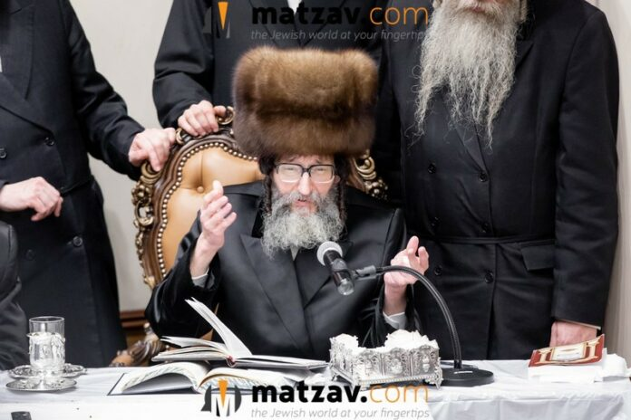

With great sadness, Matzav.com reports the petirah of the Skulener Rebbe, Rav Yeshaya Yaakov Portugal zt”l, of Boro Park, at the age of 68.
The rebbe, known for his extraordinary tzidkus and yiras Shomayim, was a beacon of Torah, chessed, and avodas Hashem, leading his Chassidim with unwavering devotion.
Rav Yeshaya Yaakov, formerly of Montreal, Canada, assumed the mantle of Skulener leadership following the petirah of his father, the Skulener Rebbe, Rav Yisroel Avrohom Portugal zt”l, over five years ago, in 2019. He was the oldest son of Rav Yisroel Avrohom and a grandson of the Skulener Rebbe, Rav Eliezer Zusia Portugal.
His father, who had survived the horrors of the Holocaust and later became renowned for his mesirus nefesh in rescuing Jewish children during Communist rule in Romania, passed on a legacy of selfless dedication to Klal Yisroel, which his son continued with distinction.

A Continuing Source of Inspiration
and Chizuk to His Many Followers
The rebbe battled illness in recent times, but continued to serve as a source of inspiration and chizuk to his many chassidim and followers. His heart was open to the pain of others, and countless Yidden flocked to him for guidance, brachos, and support. His profound ahavas Yisroel and quiet humility left an indelible mark on all who had the privilege of basking in his kedusha.
The rebbe‘s petirah leaves a deep void in the Olam HaChassidus, and his loss will be felt by the many who drew close to his warmth, chochmah, and taharah.

The Oldest Child of the
Previous Skulener Rebbe
The rebbe, as mentioned, was the oldest child of the previous Skulener Rebbe. His siblings are Rav Meir Portugal, Skulener Rebbe of Williamsburg, Brooklyn; Rav Efraim Chaim Yehuda Portugal, Skulener Rebbe of Monsey, New York; Rav Hersh Noach Portugal, Skulener Rebbe of Lakewood; Rav Shmuel Mordechai Portugal, Skulener Rov in Boro Park; Rebbetzin Leah Leba Stern, wife of Rav Chaim Dov Stern, Skulener Rov of Bnei Brak; Rebbetzin Chaya Sarah Weinberger, wife of Rav Shimon Yoel Weinberger, Skulener Dayan; and Rebbetzin Nechama Klughaupt, wife of Rav Dovid Leib Klughaupt, head of Skulener Kollel of Boro Park.
He is survived by his rebbetzin and family, and the many Chassidim who are left bereft.
The levayah was held Sunday, at noon at the Skulener Bais Medrash, located at 1315 54th Street in Boro Park, Brooklyn, followed by kevurah at the Vizhnitzer Bais Hachaim in Monsey.
Yehi zichro boruch.

Reprinted from the September 8, 2024 website of Matzav.com

